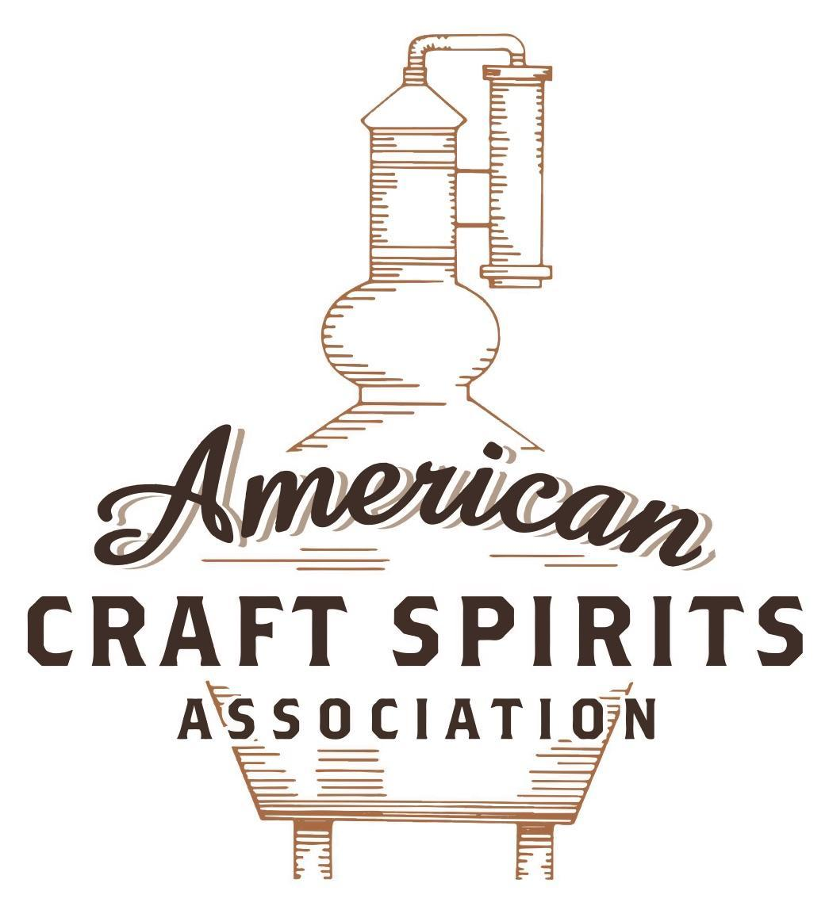
Spirits DtC Shipping Guide

This guide summarizes the direct-to-consumer shipping rules for distilleries in all 50 states and D.C. and also addresses the measures state governments have taken to ease delivery and shipping restrictions during the COVID-19 pandemic.

DtC Quick Guide Comparison

Out-of-State Distilleries  Can Ship Into State? |  |  |  | In-State Distilleries  Can Ship Within State?
State | Yes | No |  | State | Yes | No
AL |  | X |  | AL |  | X
AK | X |  |  | AK | X
AZ | X |  |  | AZ | X
AR |  | X |  | AR |  | X
CA |  | X* |  | CA |  | X*
CO |  | X |  | CO |  | X
CT |  | X* |  | CT |  | X
DE |  | X |  | DE |  | X
DC | X |  |  | DC | X
FL |  | X |  | FL |  | X
GA |  | X |  | GA |  | X
HI |  | X* |  | HI |  | ?*
ID |  | X |  | ID |  | X
IL |  | X* |  | IL |  | X*
IN |  | X |  | IN |  | X
IA |  | X* |  | IA |  | X*
KS |  | X |  | KS |  | X
KY | X |  |  | KY | X
LA |  | X |  | LA |  | X
ME |  | X* |  | ME |  | X*
MD |  | X |  | MD |  | X
MA |  | X |  | MA |  | X
MI |  | X |  | MI |  | X
MN |  | X |  | MN |  | X
MS |  | X |  | MS |  | X
MO |  | X |  | MO |  | X
MT |  | X |  | MT |  | X
NE | X |  |  | NE | X
NV |  | X* |  | NV |  | X
NH | X |  |  | NH |  | X*
NJ |  | X* |  | NJ |  | X*
NM |  | X |  | NM |  | X
NY |  | X* |  | NY |  | X*
NC |  | X |  | NC |  | X
ND | X |  |  | ND | X
OH |  | X |  | OH |  | X
OK |  | X |  | OK |  | X
OR |  | X |  | OR | X
PA |  | X* |  | PA |  | X
RI |  | X* |  | RI |  | X
SC |  | X |  | SC |  | X
SD |  | X |  | SD |  | X
TN |  | X |  | TN |  | X
TX |  | X |  | TX |  | X
UT |  | X |  | UT |  | X
VT |  | X |  | VT |  | X
VA |  | X |  | VA |  | X
WA |  | X* |  | WA | X
WV |  | X* |  | WV |  | X*

WI |  | X |  | WI |  | X
WY |  | X |  | WY |  | X

Notes:
*CA: If passed and signed into law, Senate Bill 620 would allow licensed distilled spirits producers in states other than California and licensed distilled spirits manufacturers or craft distillers in California who obtain distilled spirits direct shipper permits to ship directly to consumers in California
*CT: Consumers with appropriate permit may receive alcohol shipments
*HI: Consumers with appropriate permit may receive alcohol shipments; If passed and signed into law, Senate Bill 65 would allow licensed distilled spirits manufacturers in Hawaii and in states other than Hawaii who obtain direct shipper permits to ship directly to consumers in Hawaii
*IL: If passed and signed into law, Senate Bill 0532 would allow licensed distilled spirits producers in Illinois and in states other than Illinois who obtain distillery shippers’ licenses to ship directly to consumers in Illinois
*IA: If passed and signed into law, House File 639 would allow native distilled spirits manufacturers in Iowa and in states other than Iowa who obtain direct shipper permits to ship directly to consumers in Iowa and to consumers in states other than Iowa
*ME: If passed and signed into law, Legislative Document 1358 would allow distilleries outside of Maine with current manufacturer licenses and distilleries licensed in Maine who obtain spirits direct shipper licenses to ship directly to consumers in Maine
*NJ: (1) If passed and signed into law, Assembly Bill 3167 would allow a craft distillery licensees to ship no more than 9 liters of distilled spirits to a consumer in New Jersey; (2) If passed and signed into law, Senate Bill 3020 would allow craft distillery licensees in New Jersey or in states other than New Jersey to ship no more than 20 liters of distilled spirits to a consumer in New Jersey via common carrier
*NV: Licensed individuals can import one gallon per month of spirits for personal use and the out-of-state supplier must pay excise tax
*NH: If passed and signed into law, Senate Bill 125 would allow licensed liquor manufacturers who obtain direct to consumer shipping permits from the commission to ship directly to consumers in New Hampshire
*NY: Consumer may import up to 90L of liquor per year for personal use without a license; If passed and signed into law, Assembly Bill 3275 would allow licensed liquor manufacturers in states other than New York and licensed distillers and farm distillers in New York to ship no more than thirty-six cases (no more than nine liters per case) of liquor to consumers in New York
*PA: Consumer may place a special liquor order and distiller must ship to a PLCB-operated store
*RI: Distiller can only ship to customer if order was personally placed by customer at distiller's premises
*WA: If passed and signed into law, House Bill 1432 would allow licensed spirits manufacturers in states other than Washington to ship spirits to consumers in Washington
*WV: Distilleries, mini-distilleries, or micro-distilleries licensed in West Virginia or a state other than West Virginia who obtain private direct shipper licenses to ship to a consumer in West Virginia, however the shipments must be made to a retail liquor outlet

MARYLAND
Shipment Outbound – Yes, if the consumer is allowed to receive the alcohol in their state (Md. Alcoholic Beverages Code Ann. § 2-202; 203).
Shipment Inbound – No (Md. Alcoholic Beverages Code Ann. § 6-327).
Shipment Intra-state – No (Md. Alcoholic Beverages Code Ann. § 2-214).
COVID-19 Measures – As long as MD remains in a state of emergency, distillers can ship directly to consumers using common carriers (Executive order 20-05-29-01 and Bulletin AB - 70). Emergency mandates and restrictions ended on July 1, 2021 and the 45-day grace period ended on August 15, 2021. H.B. 1232, signed and enacted into law on May 18, 2021, allows a Class 1 distillery license holder and a Class 9 limited distillery license holder to sell and deliver products manufactured by the license holder to a consumer in Maryland who is at least 21 years of age if the delivery is made by an employee who is at least 18 years old and is certified by an approved alcohol awareness program. A holder of a manufacturer’s license may ship alcohol directly to a consumer on request if the commission authorizes the direct shipment. This emergency measure will remain in effect through December 31, 2022. (S.B. 821 is the Senate version of the bill.)
Governor Hogan Announces End of COVID-19 State of Emergency Link: https://governor.maryland.gov/2021/06/15/governor-hogan-announces-end-of-covid-19-state-of-emergency/
H.B. 1232 Link: http://mgaleg.maryland.gov/2021RS/Chapters_noln/CH_360_hb1232t.pdf
Citation (shipment)
Maryland Alcoholic Beverages Code Annotated
§ 2-202. Class 1 distillery license
(c) A license holder may:
(2) sell and deliver the alcoholic beverages:
(i) in bulk to a person in the State that is authorized to acquire them; and
(ii) to a person outside the State that is authorized to acquire them;
Link:
https://govt.westlaw.com/mdc/Document/N858F2000D2E711EB825FC22BFCF76B4F?viewType=FullText&originationContext=documenttoc&transitionType=CategoryPageItem&contextData=(sc.Default)
§ 2-203. Class 9 limited distillery license
(c) A holder of the limited distillery license:
(4) may sell and deliver those products manufactured under the license only to a licensed wholesaler in the
State or person authorized to acquire distilled spirits in another state and not to a county dispensary;
(5) may sell the products manufactured under the license at retail in a manner consistent with the underlying
Class D or Class B license;
Link:
https://govt.westlaw.com/mdc/Document/NAD93AE90B8CF11EBB816EB11889B68F9?viewType=FullText&originationContext=documenttoc&transitionType=CategoryPageItem&contextData=(sc.Default)
§ 2-214. Sale or delivery restricted
(a) Except as otherwise provided with respect to a 1-day license in Division II of this article, and subject to subsection (b) of this section, a holder of a manufacturer's license may not sell or deliver alcoholic beverages to a person in the State that does not hold a license or permit under this article.
Link:
https://govt.westlaw.com/mdc/Document/NEE2037A006A811E6BF24C8A7F6301815?viewType=FullText&originationContext=documenttoc&transitionType=CategoryPageItem&contextData=(sc.Default)
§ 6-327. Unlicensed out-of-state sale of alcoholic beverages
Prohibited
(a)(1) A person in the business of selling or distributing alcoholic beverages in or from another state may not ship, cause to be shipped, or deliver alcoholic beverages directly to a recipient in the State if the seller, distributor, shipper, transporter, or recipient does not hold the required license or permit.
(2) The prohibition under paragraph (1) of this subsection applies to alcoholic beverages ordered or
purchased through a computer network.

Penalty
(b) A person who violates this section is guilty of a felony and on conviction is subject to imprisonment not exceeding 2 years or a fine not exceeding $1,000 or both.
Link:
https://govt.westlaw.com/mdc/Document/N2C8746002D8211E6BDB8F71DBFB0E872?viewType=FullText&originationContext=documenttoc&transitionType=CategoryPageItem&contextData=(sc.Default)
Citation (COVID-19)

ORDER OF THE GOVERNOR OF THE STATE OF MARYLAND NUMBER 20-05-29-01 AMENDING AND RESTATING ORDER NO. 20-03-19-02, ENABLING ALTERNATIVE ALCOHOL SERVICES
III. State-licensed manufacturers of alcohol may:
b. directly ship alcohol to consumers upon request, provided that the Comptroller has given authorization after determining that:
i. the shipment can be completed safely using a common carrier in accordance with other applicable law; and
ii. all applicable sales and excise taxes are paid.
IV. This Order remains effective until after termination of the state of emergency and the proclamation of the catastrophic health emergency has been rescinded, or until rescinded, superseded, amended, or revised by additional orders.
Link:
https://static1.squarespace.com/static/5ae22b0d96e76f148e343642/t/5ed1653f108e5978fb3b5b98/1590781247609/Alcohol Services-AMENDED-5.29.20.pdf
Comptroller of Maryland, Bulletin AB – 70
2. Upon receipt of an Emergency Authorization for Direct-to-Consumer Alcohol Shipments from the Comptroller of Maryland, the authorized Manufacturer must:
a. Sell ONLY THE LICENSEE’S OWN MANUFACTURED ALCOHOL PRODUCTS through delivery by the holder of a common carrier permit to a Maryland consumer by receiving and filling orders that the consumer transmits by electronic or other means;
b. Verify at point-of-sale (via third-party age verification technology) AND point-of-delivery (via coordination with common carrier) that they will only sell alcoholic beverages to consumers who are at least 21 years of age, are a resident of Maryland, and who intend to purchase said alcohol for personal consumption only and not for resale or other commercial purposes;
c. Ensure that all containers of alcohol shipped directly to a consumer in the State are conspicuously labeled with: (i) The LICENSE OR PERMIT TYPE and NUMBER indicated on the valid Maryland license; (ii) The name and address of the consumer who is the intended recipient; and (iii) The words “Contains Alcohol: Signature of Person at Least 21 Years of Age Required for Delivery;”

d. Collect and remit sales tax and alcoholic beverage tax due on sales to consumers in Maryland, and file a quarterly alcoholic beverage tax return and a quarterly sales and use tax return with the Comptroller of Maryland that states the total amount of alcohol, by type, shipped direct-to consumers, the price charged, and the name and address of each purchaser;
e. Maintain, for a period of 3 years, the complete and accurate records of all information needed to verify compliance;
f. Allow the Comptroller to perform an audit of direct-to-consumer alcohol sales records on request;
g. Consent to the jurisdiction of the Comptroller of Maryland or other State unit and the State courts concerning enforcement of the Emergency Authorization for Direct-to-Consumer Alcohol Shipments and any related law.
Link: https://interactive.marylandtaxes.gov/forms/Tax_Publications/Tax_Bulletins/Alcohol_Tax_Bulletins/bl_ab70.pdf

The American Craft Spirits Association (ACSA) is working diligently to give our members and industry partners relevant, current updates on statutes and regulations impacting production, sale and distribution of spirits. With the declaration of the novel coronavirus (COVID-19) in early 2020, many states have issued temporary policy changes or longer-term modernization of alcohol beverage laws. State statutes, regulations created by the state alcohol regulatory authority, as well as any other relevant guidance provided by such authorities (such as advisories, opinions, bulletins, etc.) were reviewed in creation of this document. No city or county ordinances were reviewed. Distillers should be aware that even in states where direct shipping is permissible, always remember to avoid shipping to dry counties. Please consult with your state guild or alcohol beverage authority for the most up-to-date information. This content is intended for educational and informational purposes only. ACSA's pro bono law firm of Malkin Law P.A. provided the core content found in this comprehensive overview of the spirits distribution after COVID-19. It was completed in August 2021 and will be updated regularly. If you have updates you would like to provide, please send to legislation@americancraftspirits.org or directly to the law firm at: ryan@malkin.law / malkin.law. Thank you.

